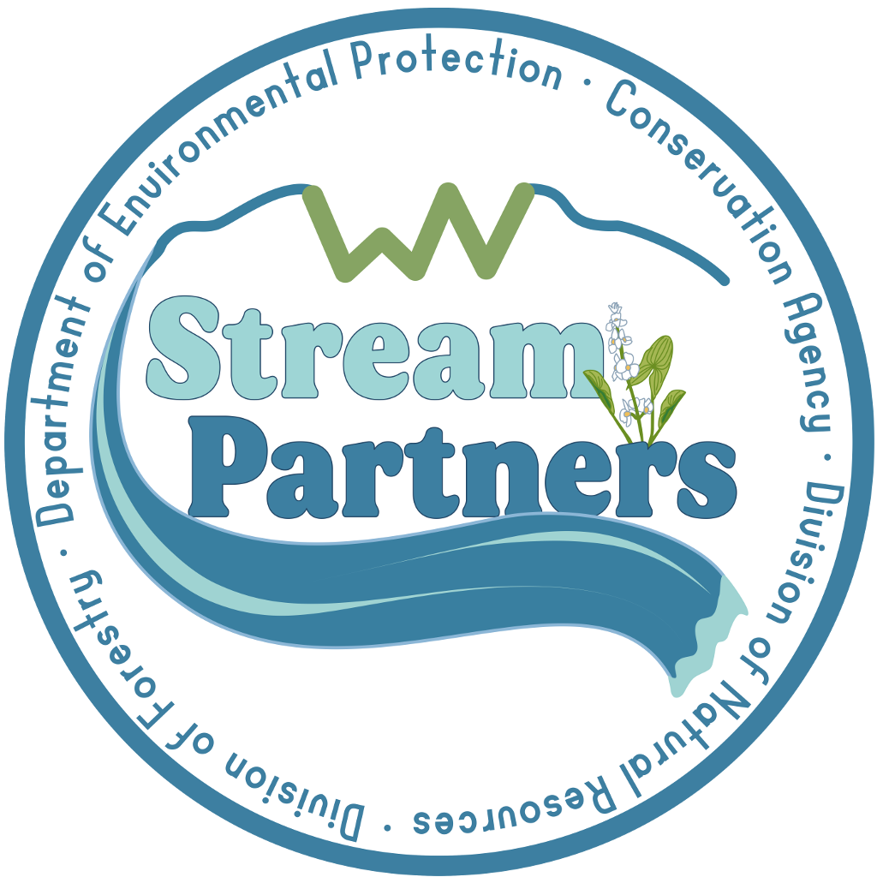
Example Application Form
Please use this document to work through your application with your group and/or Basin Coordinator before you submit it online.

Online Application Link: https://forms.gle/84DAWk6cT3y9RFes7

Grant Year:
Name of your Organization:
Mailing Address of Organization:
Name of Primary Contact:
Email Address of Primary Contact:
Name of Secondary Contact:
Email Address of Secondary Contact:
Federal Employer Identification Number (FEIN) provided by the IRS:
Name of the Watershed where the work will be focused:

1. Provide a brief description of your project(s) for this grant year. (10 pts)
Projects must address the issues that affect your stream’s health and meet the purpose of the Stream Partners Program, which is to improve water quality, increase public recreational uses, and enhance habitat.

Please Note: If your project is partially funded by another grant, you must still describe the project the SPP funds will be supporting.

2. Describe the project need. (10 pts)
Why is this project needed? What impairments exist in this stream? Or, what problems need to be addressed in the watershed? What evidence do you have to reference? (The 303.d list, monitoring data, SOS data, photos, etc.)

3. Describe the stream monitoring or improvement project your group plans to implement and how it will address the need stated above. (10 pts)
Be specific about the actions you will take. Include the measurable outputs. Example: Sandy Mine Creek is degraded by AMD. We will monitor Trib 1, Trib 2, and Trib 3 of Sandy Mine Creek to determine the source and present a proposal for next steps and/or remediation.

4. Describe the education and outreach activities your group will conduct to educate community members about the benefits of restoring, protecting, and enhancing the watershed in a responsible manner. (10 pts)
What gaps in education about the watershed exist in the community? How will this project address them?

5. Capacity: Describe your organization’s capacity, your staff or volunteer knowledge, skills, and abilities and any other relevant information that will help us understand your organization’s ability to fulfill the project objectives and outputs. (10 pts)
Have you fulfilled similar grants in the past? Other relevant information that shows your group has the capacity to complete this project?

6. Provide a budget narrative. (10 pts)
Describe how your budget relates to your project and project activities.

7. Itemized Budget (40 pts)
The budget must be a detailed and itemized list of all materials needed for the implementation of the project and outreach efforts.

The maximum amount that can be awarded is $5,000 and it requires, but is not limited to, a 20% match (which could be cash or in-kind services). If your project is funded with additional funds list the total cost of the project in the budget with other resources as match.

The budget must be a detailed and itemized list of all materials needed for the implementation of the project and outreach efforts.

Administrative costs cannot exceed 20% of the total budget.

The full grant award may be used towards a match for an AmeriCorps VISTA.

Note: SPP provides a sample spreadsheet budget that should be used as a template and submitted as an attachment. To download this template, visit: https://www.wvca.us/stream/SPApp.cfm and download the "Sample Budget" on the left side bar.

